Setup Menu

Hew Lines VA7HU and Aki Yoshida JA1NLX

1.0 General

Logger32 utilizes two standard Windows menus, the Main Menu and Setup Menu. The Setup Menu enables the user to access the following Logger32 Setup functions:

SM_1

2.0 HIGHLIGHT MENU ITEM

The HIGHLIGHT menu item allows the user to configure and show the following selectable highlight options for Grids displayed in Logger32:

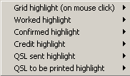

SM_2

  - Grid Highlight (on mouse-click). These options display a WIndows Color dialog box that the user can use to set the Foreground (Text) and Background colors of a Grid line that has been selected;

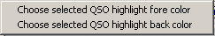

SM_3

  - Worked highlight. This option allows the user to:

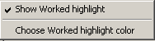

SM_4

    - Show or Hide the Worked highlight color; or,
    - Set the Background color for contacts with a state of Worked (W).

  - Confirmed highlight. This option allows the user to:

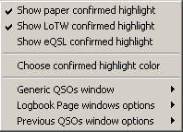

SM_5

    - Show or Hide the highlight color for contacts Confirmed by paper QSL;
    - Show or Hide the highlight color for contacts Confirmed by LoTW;
    - Show or Hide the highlight color for contacts Confirmed by eQSL;
    - Set the Background color for contacts with a state of Confirmed (C);
    - Highlight the Row or Callsign for Confirmed contacts in the Generic QSOs window;
    - Highlight the Row or Callsign for Confirmed contacts in the Logbook Page window; and,
    - Highlight the Row or Callsign for Confirmed contacts in the Previous QSOs window;

  - Credit highlight. This option allows the user to:

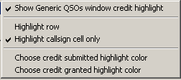

SM_6
    - Show or Hide the the highlight color of the Generic QSOs window for contacts with an Award credit;
    - Highlight the Row or Callsign for contacts in the Generic QSOs window;
    - Set the Background color of the Generic QSOs window for contacts with an Award credit that has been submitted; and,
    - Set the Background color of the Generic QSOs window for contacts with an Award credit that has been granted.
  - QSL sent highlight.

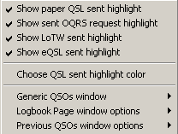

SM_7

    - Show or Hide the the highlight color for contacts sent a paper QSL;
    - Show or Hide the the highlight color for contacts sent an OQRS request;
    - Show or Hide the the highlight color for contacts sent an LoTW confirmation;
    - Show or Hide the the highlight color for contacts sent an eQSL confirmation;
    - Set the Background color for contacts that have been sent a confirmation;
    - Highlight the Row or Callsign in the Generic QSOs window for contacts that have been sent a confirmation;
    - Highlight the Row or Callsign in the Logbook Page window for contacts that have been sent a confirmation;; and,
    - Highlight the Row or Callsign for contacts in the Previous QSOs window for contacts that have been sent a confirmation;;

  - QSL to be printed highlight.

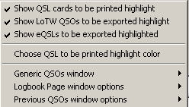

SM_8
    - Show or Hide the the highlight color for contacts with a paper QSL flagged for printing;
    - Show or Hide the the highlight color for contacts with an LoTW confirmation flagged for exporting;
    - Show or Hide the the highlight color for contacts with an eQSL confirmation flagged for exporting;;
    - Set the Background color for contacts that have a paper QSL flagged for printing or a confirmation flagged for exporting;
    - Highlight the Row or Callsign in the Generic QSOs window for contacts that have been sent a confirmation;
    - Highlight the Row or Callsign in the Logbook Page window for contacts that have been sent a confirmation; and,
    - Highlight the Row or Callsign for contacts in the Previous QSOs window for contacts that have been sent a confirmation;;

3.0 DATE FORMAT MENU ITEM

The DATE FORMAT menu item allows the user to select the Date format to be used by Logger32 from a drop-down menu.

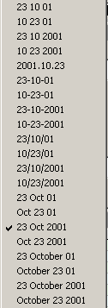

SM_9

4.0 TIME FORMAT MENU ITEM

The TIME FORMAT menu item allows the user to select the Time format to be used by Logger32 from a drop-down menu.

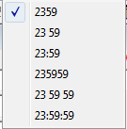

SM_10

5.0 RADIO MENU ITEM

The RADIO menu item allows the user to:

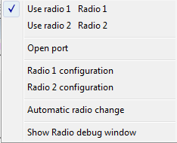

SM_11

  - Use radio 1

  - Use radio 2

  - Open and Close (toggle) the Radio port

  - Setup Radio 1 configuration

  - Setup Radio 2 configuration

  - Automatically change the radio

  - Show the Radio debug window

6.0 CD ROM MENU ITEM

The CD ROM menu item allows the user to select a CDROM Callbook to be used by Logger32 from the following list:

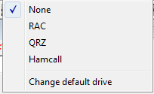

SM_12
  - None;
  - RAC;
  - QRZ;
  - HamCall; or to
  - Change the default drive

7.0 AUTO LOOK UP MENU ITEM

The AUTO LOOKUP menu item allows the user to configure Logger32 to automatically search for callsign data from one of the following selections, when a callsign is entered into the Logbook Entry window:

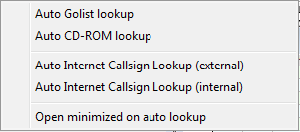

SM_13

  - Auto Golist lookup;
  - Auto CD-ROM Lookup;
  - Auto Internet Callsign Lookup (external);
  - Auto Internet Callsign Lookup (internal);
  - Open minimized on auto lookup.

8.0 FREQUENCY MENU ITEM

The FREQUENCY menu item allows the user to select the frequency format to be used by Logger32 from a drop-down menu list.

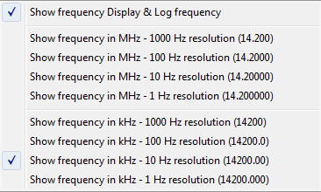

SM_14

9.0 ANTENNA SELECTOR MENU ITEM

The ANTENNA SELECTOR menu item displays the Antenna Selector dialog box that enables the user to configure Logger32 to use an electronic antenna switch to automatically select different antennas for different bands. Details can be found in the Setup Antenna Selector topic.

10.0 ROTOR MENU ITEM

The ROTOR menu item allows the user to interface Logger32 to an antenna rotator using an RS-232 serial interface. Details can be found in the Setup Antenna Rotator topic.

11.0 DX SPOT MENU ITEM

The DX Spot menu item allows the user to setup the DX Spots message interface and message data for Logger32 to send from the Logbook Entry Window.

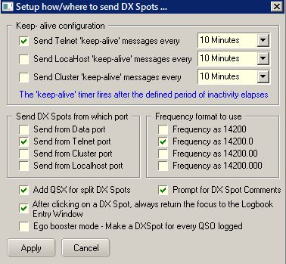

SM_15

  - Configure the port Keep Alive functionality;

  - Select the Port (interface) to be used;
  - Define the Frequency format to be used in the message and incoming spot;
  - Include the QSX data in the message for split operations;
  - Prompt for comments to add to the message; and,
  - Return the cursor to the Logbook Entry window upon message completion.

If you prefer to operate in Ego trip booster mode then check this option. If you check this option then new button appears.

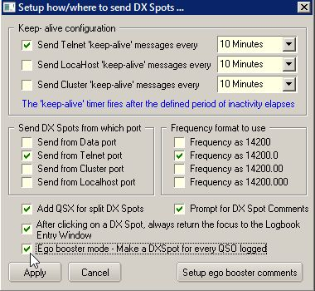

CWM_15A

Click the Setup ego trip comments button.

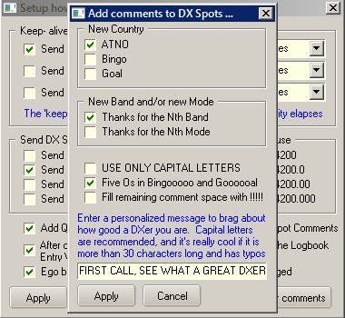

CWM_15B

Check your favorite options and click Apply. Now ready to go. DX spot with ego comment will be sent whenever QSO is logged. Ego comment is automagically generated by Logger32. You can add personalized message too. Some ego comment samples below.

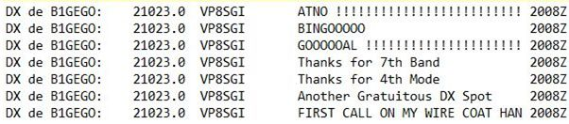

CWM_15C

12.0 HAM CAP MENU ITEM

The Ham CAP menu item displays the Ham CAP setup dialog box to configure the default configuration of the Ham CAP propagation prediction program.

13.0 LANGUAGE MENU ITEM

The Language menu item displays the current language configured for Logger32 and the instructions to change that language.

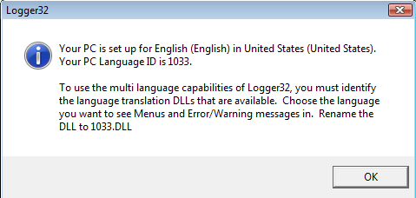

SM_16

14.0 UPDATES MENU ITEM

The Updates menu item provides the capability to configure and enable the Update functions of Logger32.

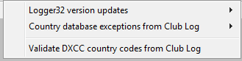

SM_17

14.1 Logger32 Version Updates

The “Logger32 version updates” brings Logger32 up to the latest public release. This update can be set to run automatic or manual. If the automatic update option is selected, Logger32 will automatically poll the internet location 10 seconds after each startup of Logger32. The manual update can be initiated at operator discretion. You can also read the latest release notes.

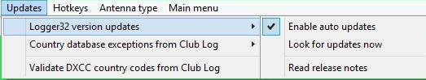

SM_17A

14.2 Country Database Exceptions

The “Country database exceptions” updates the Logger32 database callsign exceptions list to match the current Club Log records. This update brings Logger32 database in line with individual Callsign and Expeditions based on activation dates as known by the Club Log records.

The "Country database exceptions" “Full Prefix synchronization” will update the Logger32 country database to match the Club Log database. This option will update both the PFX and callsign exceptions. This option will should be repeated daily if "Enable auto update' is checked, or you should run "Look for updates now" at least weekly. monthly following an initial update.

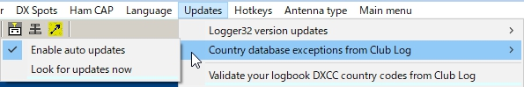
new SM_17B
14.2 Validate DXCC Country Codes
The "Validate DXCC country codes" will update the user logbook to show the proper DXCC assignment. This validation is based on the Club Log knowledge base and are based on the actual time periods of specific operations. This option can be run automatic or manually at operator discretion. If manual mode is selected, the operator will be prompted for approval where Logbook differs from the Club Log record. If the user has evidence such as QSL card supporting validity of the logbook record, it is suggested that the evidence be presented to the Club Log help desk so they can update their records. There is also an option to leave the logbook records as is when the QSO already has ARRL confirmation.

This validation updates the statistics automatically unless the operator chooses to do it later to speed up the process.
Note: This function modifies your Logbook records. Recommend a full logbook backup before proceeding.
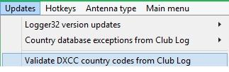
SM_17C

15.0 HOTKEYS MENU ITEM

The Hotkeys menu item provides a list of items that can be "checked" to enable global hotkeys within Logger32. The default setting is off (not checked and it is recommended that if you don't use hotkeys, you leave them off.

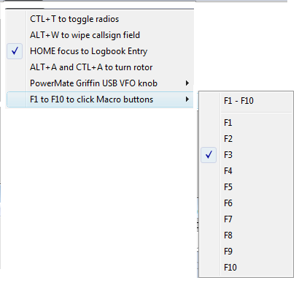

SM_18

16.0 ANTENNA TYPE MENU ITEM

The Antenna Type menu item provides the capability to select either the SteppIR antenna controller or the Ultra Beam antenna controller..

17.0 MAIN MENU ITEM

The MAIN MENU menu item allows the user to switch back to the Main Menu bar.

